Is This the Year for MSPB Rights for all EAS Employees?
March 4, 2021
By Ivan D. Butts
NAPS Executive Vice President

As we continue formulating our NAPS legislative agenda for 2021, we prepare with new enthusiasm for a labor-leaning administration, House and Senate. Albeit slim in margins, now is the time for labor groups to move labor issues from pie-in-the-sky ideas to actual legislation.
NAPS has long championed our issue concerning MSPB rights for all EAS employees with the steadfast support of Rep. Gerry Connolly (D-VA). He has consistently introduced this important legislation yearly via his role on the House Oversight and Reform Committee. The latest iteration was H.R. 597, the “Postal Employee Appeal Rights Amendments Act.” The legislation was introduced during the 116th session of Congress with Rep. David B. McKinley (R-WV) as original cosponsor.
NAPS is forever grateful for the hard work and dedication of late NAPS Branch 244 President Mary Burkhard who raised awareness about this vital issue that negatively affects USPS EAS employees. Mary brought needed light to the inequity of the ELM 650 hearing process. This is the system for adjudicating adverse actions for employees who are being impacted by not having access to the Merit Systems Protection Board (MSPB) courts.
Congress must clarify current law to ensure that all Postal Service employees in the Executive and Administrative Schedule may appeal adverse personnel actions to the MSPB. Currently, 7,500 nonsupervisory management personnel are locked out of MSPB appeal rights.
H.R. 597 would correct the situation and assure MSPB access to all Postal Service non-bargaining employees, regardless whether or not they supervise USPS operations. The legislation also would extend MSPB appeal rights to USPS Office of Inspector General employees.
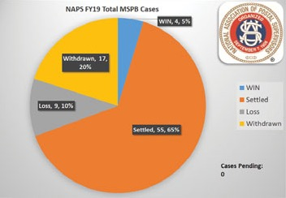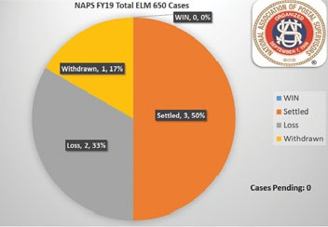
NAPS will move this legislative agenda item forward this year with additional data I have been able to gather and maintain with the assistance of our DDF provider, Labor Relations Admin Group, LLC. The data validates that MSPB rights for all issues are at de minimis cost in the scoring process for legislation due to the volume of cases per year that currently must be heard in the ELM 650 hearing process.
Our data also shows a total disparity in adjudicating cases in the MSPB courts and the lesser ELM 650 hearing process. The graphs show this inequity in a bold and defined manner, noting that, in the past two years, NAPS has not prevailed with a victory in any ELM 650 hearing.
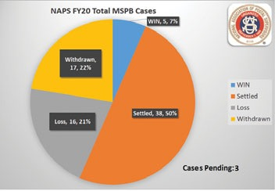
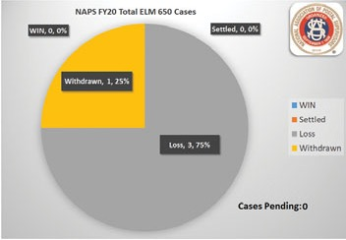

It would be an excellent accomplishment for NAPS and equally great testimony to the tireless work of Mary Burkhard if NAPS, with the help of our legislative champions, can make MSPB rights for all EAS employees a reality in the 117th Congress.
In solidarity…

